Internal iliac artery

Area of supply
It is the artery of pelvic organs. Also supplies gluteal region, perineum and adductor compartment of the thigh

Origin
Arises as smaller terminal branch of the common iliac artery
Arise in front of sacroiliac joints at the level of L5

Course
Descends posteriorly towards the greater sciatic notch
Here it terminates by dividing into the anterior and posterior divisions

Posterior division of internal iliac artery
​​​​​​​Has three parietal branches
Branches

1. Iliolumbar artery
Located behind the obturator nerve
Supply iliacus muscle and tissues of iliac fossa

2. Superior gluteal artery
Passes between the lumbosacral trunk and the ventral ramus of S1
Superior gluteal vessels and nerve are located very close to each other
Superior gluteal artery runs very close to sharp bony margin of the greater sciatic foramen
Supply - upper part of the gluteal maximus, gluteus medius and minimus

3. Lateral sacral arteries (2/3 in number)
Runs in front of the sacral plexus
Supply - sacral vertebrae and spinal nerve roots
In significant number of individuals - inferior gluteal and obturator arteries arise from posterior division

Anterior division of internal iliac artery
​​​​​​​Has three parietal branches and three visceral branches.

Visceral branches
- Umbilical artery
- Uterine artery
- Inferior vesical artery
In some individuals - Middle rectal artery

Parietal branches
- Obturator artery
- Internal pudendal artery
- Inferior gluteal artery
Middle rectal artery
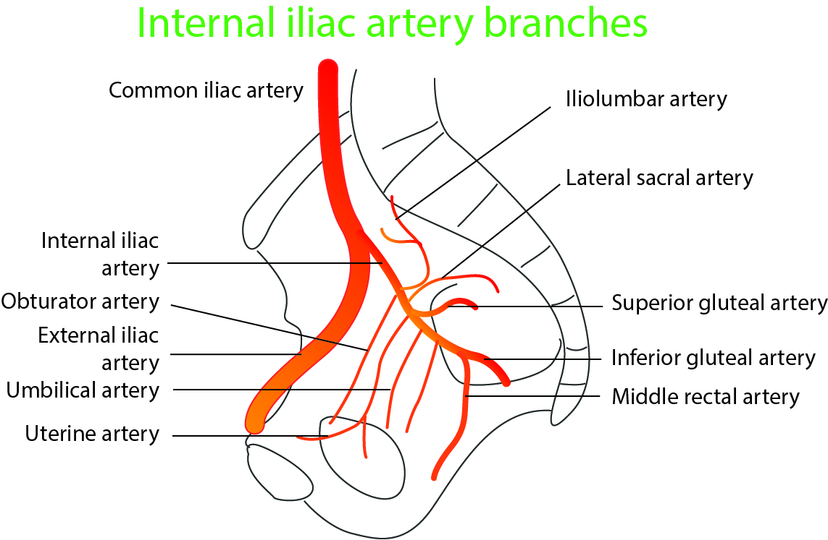

Anterior division
Visceral branches
- Umbilical artery
- Uterine artery
- Inferior vesical artery
In some individuals - Middle rectal artery
Parietal branches
- Obturator artery
- Internal pudendal artery
- Inferior gluteal artery
Middle rectal artery

Posterior division
- Iliolumbar artery
- Superior gluteal artery
- Lateral sacral arteries (2/3 in number)

Umbilical artery
Proximal part remain patent and superior vesical artery is a branch of this
Often arise as a single stem - from which uterine artery branches out
Note:
- Umbilical artery - Carry deoxygenated blood from the foetus to placenta
- Uterine artery - carry blood to the uterus (through placenta to foetus)
Arise as single stem - from the internal iliac artery

Uterine artery
Crosses the floor of the pelvis in the parametrium
Arise from the same vascular stem along with umbilical artery

Course:
Passes medially from its origin
Towards uterine isthmus
Crosses over the ureter (water under the bridge) at 1.5 cm lateral to the uterine cervix
At cervix the artery ascends up along the lateral wall of the uterus
Anastomose with the ovarian artery along the uterine tube
Homologous branch of uterine artery in male is differential branch of inferior vesical artery

Vaginal artery
Multiple - May be a branch of uterine artery or direct branches of internal iliac artery

Obturator artery
​​​​​​​Located within the lateral pelvic wall, along with obturator nerve
Aberrant / accessory obturator artery - if present arise from inferior gluteal artery
- Related to ligament of Gimbernat
- Related to femoral ring and runs over Cooper's ligament
- If both obturator and accessory obturator artery are present in the same individual - such anastomosis is called circle of death - there may be severe bleeding if either artery is accidently cut during the surgery

Internal pudendal artery
​​​​​​​Leaves pelvis by passing through greater sciatic foramen
Pudendal nerve, Internal pudendal artery, and Nerve to obturator internus (PIN structures) are located in this region
Crosses the sacrospinous ligament
Enters the Alcock's canal
Supplies ischiorectal fossa and urogenital structures

Inferior gluteal artery
​​​​​​​Passes through the greater sciatic foramen along with inferior gluteal nerve
Supply lower part of gluteus maximus
Middle rectal artery
Small artery, sometimes absent - specially in females
It supplies prostate tissues more than the rectum

